FIFA-2019  
Data Warehousing and Analysis

**PROJECT DESCRIPTION:**

The **Fédération Internationale de Football Association**, French for **International Federation of Association Football**; Spanish: Federación Internacional de Fútbol Asociación; German: Internationaler Verband des Association Football) is a non-profit organization which describes itself as an international governing body of association football, fútsal, beach soccer, and efootball. It is the highest governing body of football.

**The main aim of this Data warehousing project is to analyze the following subjects:**

1. **Skill Analysis**
2. **Value Analysis**
3. **Player Analysis**
4. **Potential Analysis**
5. **BodyType Analysis**

**Subject and Research Questions**

1. **Skill Analysis**
2. What is the agility of the player?
3. What is the agility and accuracy of the player?
4. What is the agility and accuracy of the player as per his position?
5. What is the accuracy and agility of the player as per his age and position?
6. What is the accuracy according to the position?
7. What is the accuracy according to the balance?
8. **Value Analysis**
9. What is the value of a particular player?
10. What is the value of the player according to his age?
11. What is the value of the player as per his nationality?
12. What is the wage of the player as per his value?
13. The total wages of the players as per their positions.
14. The total wages of the players as per their position and potential.
15. The total wages of the players according to their strength.
16. The total wage and value of the players of different clubs.
17. **Player Analysis**
18. Player belonging to which club has what acceleration?
19. Player belonging to which club has what accuracy?
20. What is the accuracy of the player as per his potential?
21. What is the International reputation of player as per his acceleration?
22. **Potential Analysis**
23. What is the potential of the player?
24. What is the potential and accuracy of the player as per position?
25. What is the potential of the player according to his strength?
26. What is the potential of the player as per the work rate and strength?
27. What is the potential of the as per the age?
28. What is the potential of the player according to his nationality and age?
29. **BodyType Analysis**
30. Which bodytypeId has How much Longshots?
31. Which PlayerID has How much WeakFoot?
32. LongShots according to Position.
33. LongShots according to height and position.

**Dimension Modelling**

**1) PlayerDim**

|  |
| --- |
| PlayerID  Name  Age  Nationality  International Reputation  Position |

**2) SkillsDim**

|  |
| --- |
| SkillID  Skill_Moves  Work_Rate  Volleys  Dribbling  Balance |

**3) DimClub**

|  |
| --- |
| ClubID  Club  Position  Jersey_Number |

**4) DimBodyType**

|  |
| --- |
| BodyTypeId  PreferredFoot  Weak_Foot  Body_Type  Weight  Height |

**Fact Tables**

**1) FactPlayer**

|  |
| --- |
| ID  PlayerID  SkillID  International Reputation  Acceleration  Accuracy  LongShots  ShotPower  Penalties |

**2) FactValue**

|  |
| --- |
| ID  PlayerID  ClubID  Value  Wage |

**3) FactSkill**

|  |
| --- |
| ID  PlayerID  Agility  ClubID |

**4) FactBodyType**

|  |
| --- |
| ID  PlayerID  Stamina  Strength  BodyTypeID |

**5) FactPotential**

|  |
| --- |
| ID  PlayerID  Potential  Work_rate  Strength |

**Data warehouse schema**

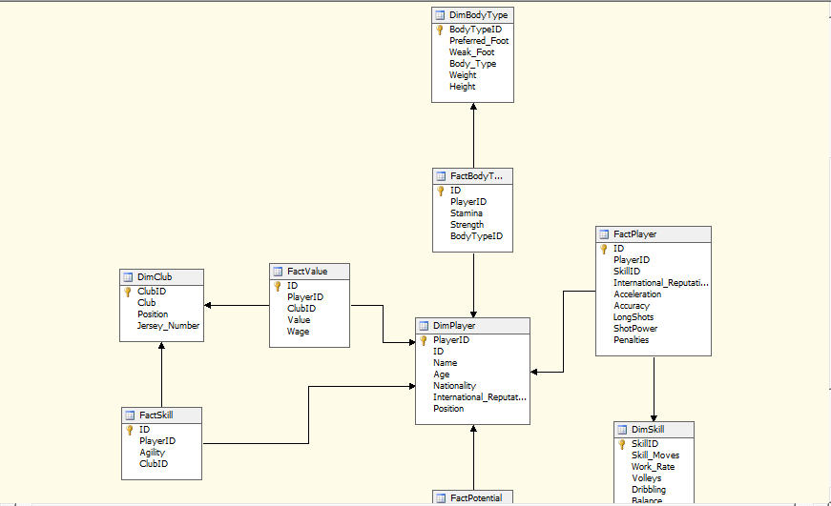

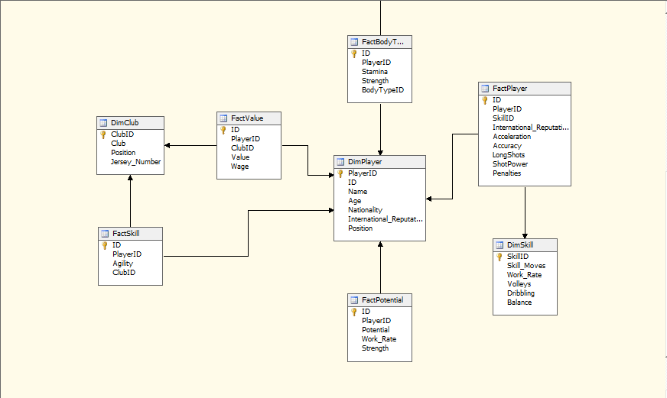

**Analysis Result**

**A) Sales Analysis**

1. What is the agility of the player?

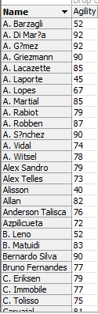

2 .What is the agility and accuracy of the player?

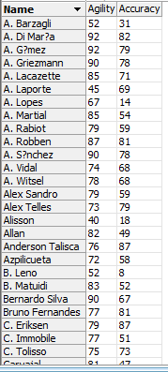

3. What is the agility and accuracy of the player as per his position?

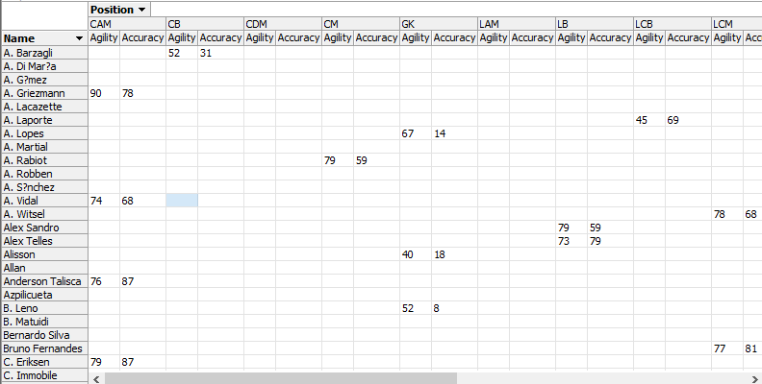

4. What is the accuracy and agility of the player as per his age and position?

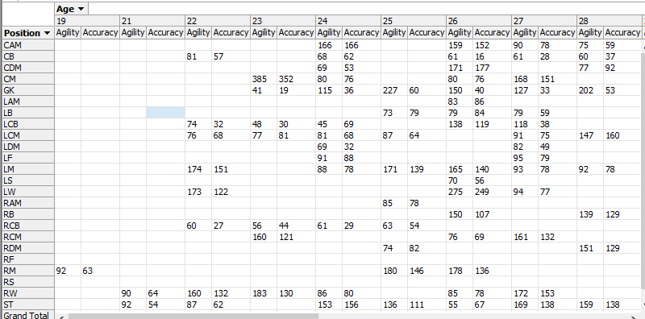

5. What is the accuracy according to the position?

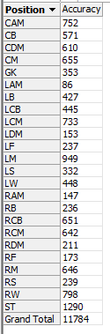

6 .What is the accuracy according to the balance?

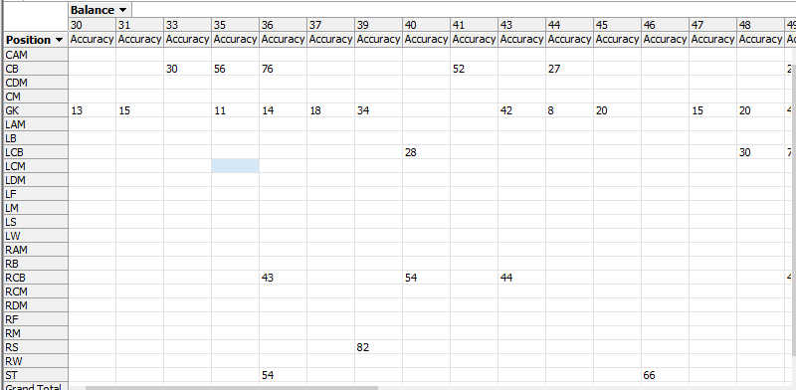

**B) Value Analysis**

1. What is the value of a particular player?

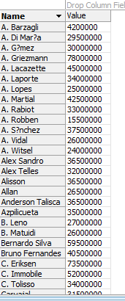

2 .What is the value of the player according to his age?



3. What is the value of the player as per his nationality?



4. What is the wage of the player as per his value?



5. The total wages of the players as per their positions.

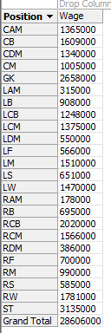

6. The total wages of the players as per their position and potential.

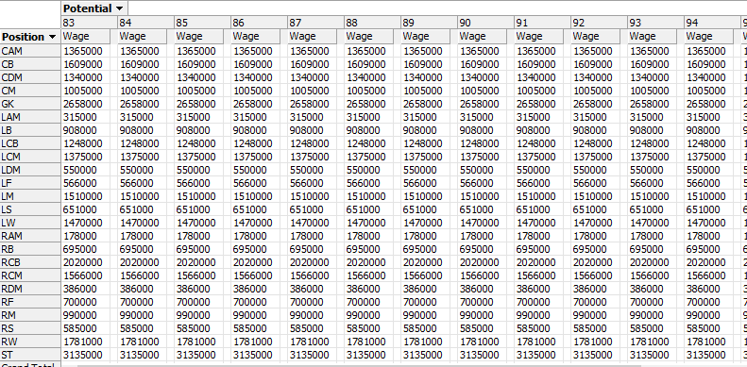

7 .The total wages of the players according to their strength.

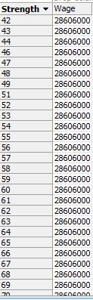

8 .The total wage and value of the players of different clubs.

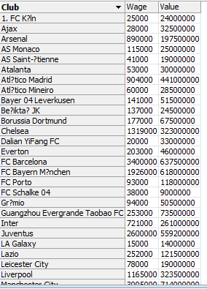

**C) Player analysis**

1. Player belonging to which club has what acceleration?

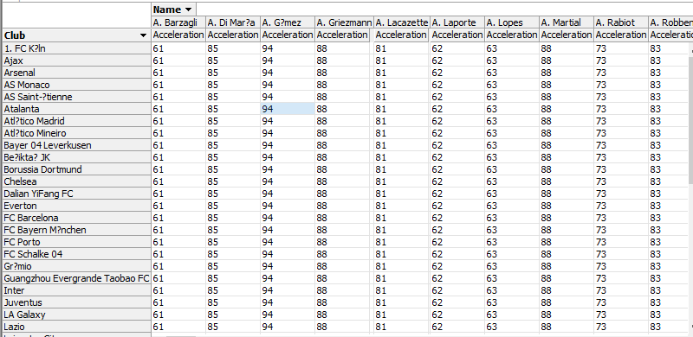

2. Player belonging to which club has what accuracy?

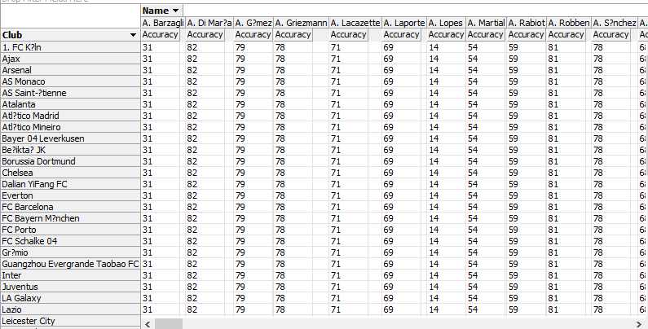

3. What is the accuracy of the player as per his potential?

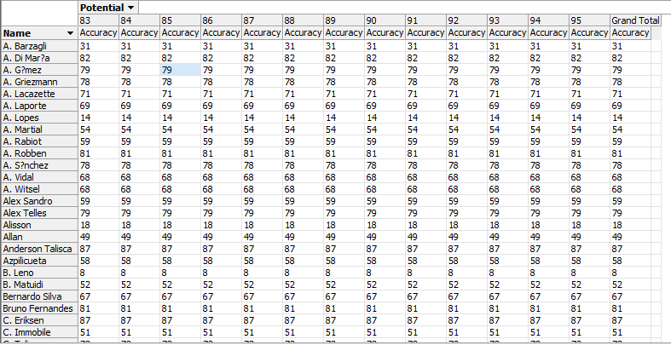

4. What is the International reputation of player as per his acceleration?

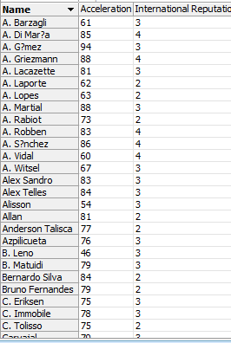

**D) Potential Analysis**

1. What is the potential of the player?

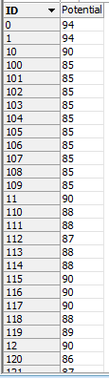

2. What is the potential and accuracy of the player as per position?

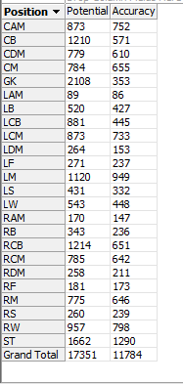

3. What is the potential of the player according to his strength?

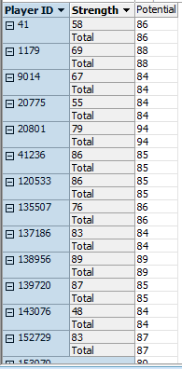

4 .What is the potential of the player as per the work rate and strength?

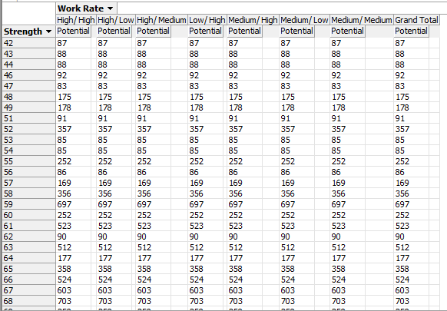

5 .What is the potential of the as per the age?

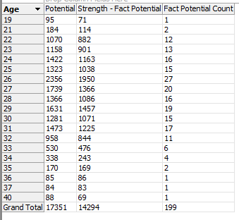

6. What is the potential of the player according to his nationality and age?

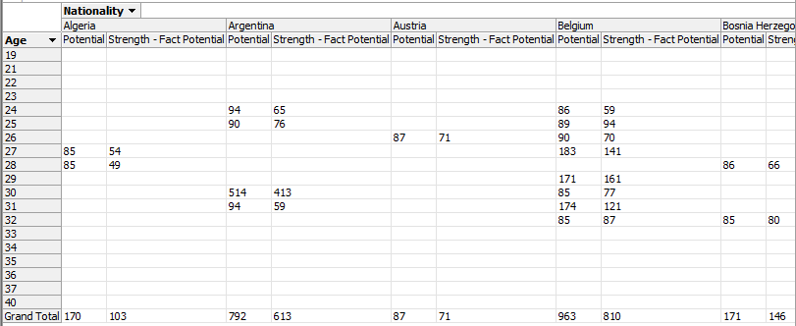

**E) BodyType Analysis**

1. Which bodytypeId has How much Longshots?

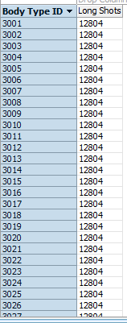

1. Which PlayerID has How much WeakFoot?

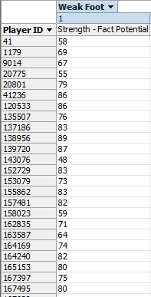

1. LongShots according to Position.

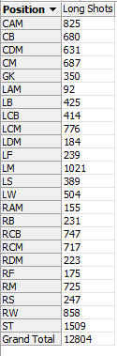

1. LongShots according to height and position.

